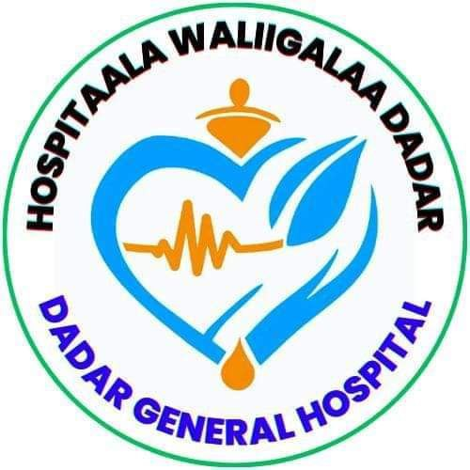**DEDER GENERAL HOSPITAL**

**Policy for Access to Hospital Premises and Traffic Flow Management**

***July 2016EC***

***Deder, Ethiopia***

**TABLE OF CONTENTS**

**1. Introduction** 1

**2. Purpose** 1

**3. Objectives** 1

4. Scope 1

5. Access Control Zones 2

**6. Entry Requirements** 2

**7. Vehicle and Pedestrian Traffic Flow** 3

**8. Visitor & Attendant Movement Regulation** 4

**9. Emergency Access Protocol** 4

**10. Roles and Responsibilities** 4

**11. Monitoring & Enforcement** 5

**12. Communication & Awareness** 5

**13. Penalties for Non-Compliance** 6

14. Summary 6

15. Review 6

16. Annexes 7

# **1. Introduction**

Unregulated access and uncontrolled movement within hospital premises pose risks to patient safety, infection control, and facility operations. This policy establishes a structured system for controlling entry, movement, and traffic flow in and around Deder General Hospital to promote a clean, secure, and patient-centered care environment.

# **2. Purpose**

To ensure safe, efficient, and infection-conscious access to hospital facilities by regulating entrances, controlling traffic flow, and enforcing access limits for various categories of individuals.

# **3. Objectives**

* Prevent unauthorized access to critical care and sterile zones.
* Reduce unnecessary foot traffic to control healthcare-associated infections (HAIs).
* Improve movement efficiency for patients, staff, and supplies.
* Safeguard the privacy, dignity, and safety of all hospital users.
* Ensure security compliance and emergency preparedness across access points.

# 4. Scope

This policy applies to all individuals entering Deder General Hospital premises including staff, patients, visitors, suppliers, contractors, and public health personnel.

# 5. Access Control Zones

|  |  |  |
| --- | --- | --- |
| **Zone** | **Access Level** | **Authorized Personnel** |
| **General Areas** (Reception, OPD Waiting) | Open access during working hours | Public, screened visitors |
| **Clinical Wards** (Medical, Surgical, Maternity, NICU) | Controlled access | Patients, designated attendants, staff with ID |
| **Restricted Zones** (Operating Room, CSSD, ICU, TB Clinic) | High control | Authorized clinical staff, IPC-cleared personnel |
| **Administrative Offices** | Staff-only | Staff with badge, visitors by appointment |
| **Waste Storage/Service Areas** | Restricted | Cleaners, facility staff, waste handlers |

# **6. Entry Requirements**

All persons entering the hospital must:

* Pass through the **main gate checkpoint** for screening.
* Wear visible **ID badges** (staff and contractors).
* Submit to **temperature checks** and **hand hygiene** (during outbreak periods).
* Provide purpose of visit and location to access.
* Use designated **visitor or staff logbooks**.

# **7. Vehicle and Pedestrian Traffic Flow**

**Pedestrian Guidelines:**

* Walk only on marked footpaths.
* Do not loiter in corridors or wards beyond permitted time.
* Follow posted directional signs, especially near isolation areas.

**Vehicle Guidelines:**

* **Ambulances and emergency vehicles** get priority access to designated zones.
* Staff vehicles must park in the **staff-only area**.
* Visitors are **not permitted to drive into patient drop-off zones** without special permission.
* No vehicles may block fire exits or oxygen delivery paths.

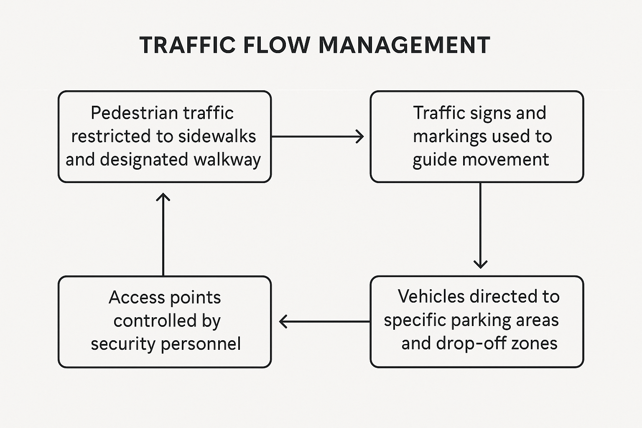

# **8. Visitor & Attendant Movement Regulation**

* Visitors are only allowed during **official visiting hours** (see Visiting Policy).
* Maximum of **two visitors per patient per day**.
* Only **one attendant per inpatient** may stay overnight, with permission from nursing supervisor.
* Movement between wards by visitors is **prohibited**.
* Security will remove individuals violating movement or access rules.

# **9. Emergency Access Protocol**

During emergencies (e.g., fire, outbreak, trauma surge), entry and movement will be governed by the hospital’s Emergency Response Plan. All gates, flow, and access rules may be temporarily suspended or rerouted under the direction of hospital command.

# **10. Roles and Responsibilities**

|  |  |
| --- | --- |
| **Role** | **Responsibility** |
| **Security Staff** | Enforce entry protocols, check ID, direct flow, maintain access logs. |
| **IPC Team** | Advise on restricted zone access, especially during outbreaks. |
| **Ward In-Charges** | Monitor and approve patient visitor access. |
| **Facility Management** | Maintain signage and traffic markings. |
| **Admin Office** | Issue staff IDs, schedule external visits and contractors. |

# **11. Monitoring & Enforcement**

* Monthly audits will be conducted at entry points by IPC and Security heads.
* Access violations will be documented and disciplinary action may apply.
* Feedback mechanisms (e.g., incident logbook, complaint box) will help identify problem areas.

Certainly. Here’s the **continuation and finalization** of the *Access Control & Traffic Flow Management Policy*:

# **12. Communication & Awareness**

To ensure understanding and compliance with the policy:

* **Orientation sessions** will be conducted for all new staff, security, and contract personnel.
* **Briefings** will be provided to patient attendants upon admission by ward nurses.
* **Clear signage** (bilingual: English and Afaan Oromoo) will be installed at key points—main gate, entrances to wards, restricted zones, and service corridors.
* **Visual maps** showing approved pathways and restricted areas will be posted at reception, OPD, and emergency entrances.

# **13. Penalties for Non-Compliance**

To maintain a safe and secure hospital environment, the following enforcement measures apply:

|  |  |
| --- | --- |
| **Violation** | **Action** |
| Unauthorized access to restricted zone | Immediate removal, warning, and report to Admin/IPC |
| Staff bypassing screening or ID protocol | Written warning and HR report |
| Contractors in patient areas without clearance | Project suspension or revocation of access |
| Visitors entering beyond allowed hours | Escorted out and logged for follow-up |
| Blocking emergency access routes (vehicles) | Vehicle towed or access revoked |

# 14. Summary

This policy ensures that the hospital functions as a secure, efficient, and infection-aware environment. Regulated movement, controlled access, and compliance with designated pathways protect patients, staff, and the public while enabling Deder General Hospital to deliver high-quality health services.

Strict implementation and continuous awareness of this policy are essential for sustaining safety and operational excellence.

# 15. Review

This policy shall be reviewed **annually**, or earlier if security incidents, construction, or outbreak situations demand revision.

# 16. Annexes

**Annex A – Access Authorization Form**

*(For vendors, contractors, or exceptional visitors)*

|  |  |
| --- | --- |
| **Section** | **Details** |
| Date of Request | __________________________ |
| Name of Visitor | __________________________ |
| Organization/Affiliation | __________________________ |
| Purpose of Visit | __________________________ |
| Areas to be Accessed | __________________________ |
| Duration of Access | From: ____ / ____ / _____ To: ____ / ___ / ___ |
| Escort Required | ☐ Yes ☐ No |
| Approved by (Dept. Head) | Name: ___________ Signature: ___________ |
| Authorized by (Admin/CEO) | Name: ___________ Signature: ___________ |
| Notes/Restrictions | __________________________ |

**Annex B – Ward Attendant Registration Log Template**

|  |  |  |  |  |  |  |  |  |
| --- | --- | --- | --- | --- | --- | --- | --- | --- |
| **Date** | **Ward** | **Patient Name** | **Attendant Name** | **ID No. / Relationship** | **Phone** | **Time In** | **Time Out** | **Nurse Signature** |
|  |  |  |  |  |  |  |  |  |
|  |  |  |  |  |  |  |  |  |
|  |  |  |  |  |  |  |  |  |

*Note: Only one active attendant per patient is allowed overnight. Daily updates required.*

**Annex C – Visitor Logbook Template (Main Gate or Ward Entry)**

|  |  |  |  |  |  |  |  |  |  |
| --- | --- | --- | --- | --- | --- | --- | --- | --- | --- |
| **Date** | **Time In** | **Visitor Name** | **Patient Visited** | **Ward** | **Purpose of Visit** | **Phone No.** | **ID Checked**☐ Yes ☐ No | **Time Out** | **Guard Signature** |
|  |  |  |  |  |  |  |  |  |  |
|  |  |  |  |  |  |  |  |  |  |
|  |  |  |  |  |  |  |  |  |  |

*Note: This log must be updated daily and stored for at least 30 days.*

**Annex D – Emergency Access Flow Chart**

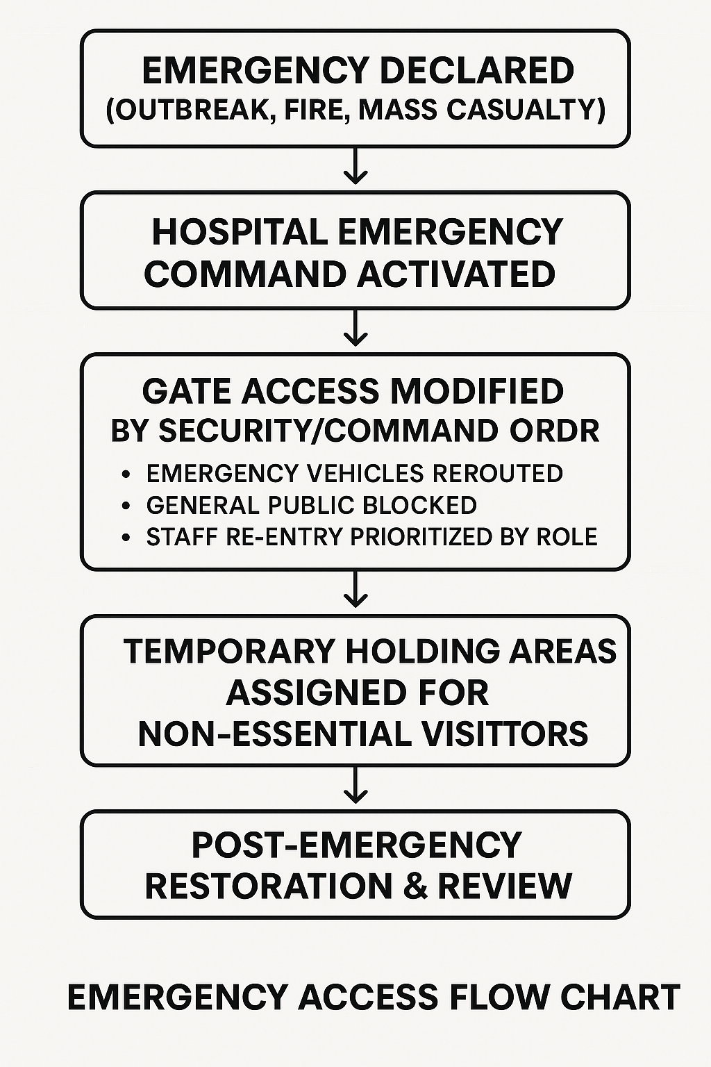

**Annex E – Hospital Access Zoning Map *(Text Description for Reference)***

|  |  |  |
| --- | --- | --- |
| **Zone** | **Access Control Level** | **Examples** |
| Zone 1 – Public Access | Open access with screening | Reception, OPD Waiting Area |
| Zone 2 – Controlled Clinical | Limited to staff/patients/attendants | Wards, Maternity, Emergency |
| Zone 3 – High-Security Clinical | Strict clearance only | OR, CSSD, ICU, TB Room |
| Zone 4 – Staff/Admin | Staff ID required | Admin Offices, HR, Finance |
| Zone 5 – Services/Support | Restricted staff access | Laundry, Waste Zone, Maintenance |

🧭 A visual version (floor map with color-coded zones) can be developed for printing or digital use.